Objective Question
Q1. What is the total no. of tables present in the data?
Ans. There are 2 sheets — "Raw Data" and "country description".

Q2. What is the total no. of attributes present in the data?
Ans. The "Raw Data" sheet has 20 columns.

Q3. How many categorical columns are there in the data? [Search about categorical and continuous data, and try to answer this question]
Ans. Categorical columns are usually those containing names, labels, or discrete non-numeric values. In "Raw Data", they are:
RestaurantName
CountryCode (numeric but actually categorical)
City
Address
Locality
LocalityVerbose
Cuisines
Currency
Has_Table_booking
Has_Online_delivery
Is_delivering_now
Switch_to_order_menu
So, 12 categorical columns out of 20.

Q4. The data consists of some inconsistent and missing values so ensure that the data used for further analysis is cleaned.
Ans. - Ensured Data Completeness: Rows with missing values in the Cuisines column were removed to maintain consistency and completeness across key attributes.
Validated Cost Entries: Records indicating an Average Cost for Two as zero were excluded, as such values are not representative of real-world pricing and could distort analytical outcomes.
Maintained Data Integrity: The Remove Duplicates function was applied to eliminate redundant entries, ensuring that each restaurant record is unique and the dataset remains free from duplication.
These preprocessing steps were essential to enhance the quality of insights derived from subsequent analysis.
Q5.Using the LookUp functions, fill up the countries in the original data using the country code.
Ans. =VLOOKUP(C2,'country description'!$A$1:$B$16,2) )

Q6. Create a table to represent the number of restaurants opened in each country.
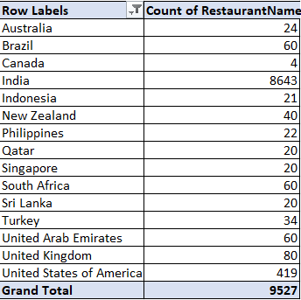

Q7. Also, the management wants to look at the number of restaurants opened each year, so provide them with something here.
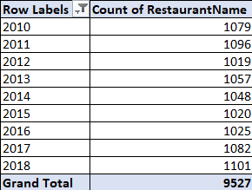

Q8. What is the total number of restaurants in India in the price range of 4?
Ans. 388
Formula: “=COUNTIFS('Raw Data'!P:P,4,'Raw Data'!U:U,"India")”

Q9.What is the average number of voters for the restaurants in each country according to the data?
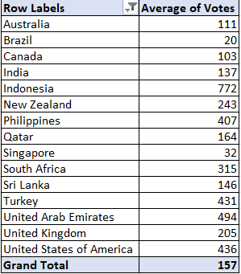

Q10.Calculate the average rating for all the restaurants that have price_range < 4 and provide online delivery. Use only the “IF” function, Logical Operators, and Aggregation functions to solve this problem. [Note: Don’t use Conditional aggregation in this question.]

Ans. 3.27381151
Formula: “=AVERAGE(IF(('Raw Data'!P:P<4)*('Raw Data'!M:M="Yes"), 'Raw Data'!S:S))”
Q11. Using Conditional formatting highlight the rows of restaurants that are located in the countries or cities that you’ve suggested to the management for opening new restaurants.

Ans. Countries Are: Singapore, United Kingdom, United Arab Emirates
Criteria: The countries indicated with operational efficiency, customer satisfaction, listing density, delivery-reservation balance, premium potential, brand elevation, scalability, urban adaptability, experience-led growth.
Conditional Formatting: go to “New Rule” button and go to “Use a rule to determine which cells to format” tab and write the below formula for highlighting entire rows with suggested countries.
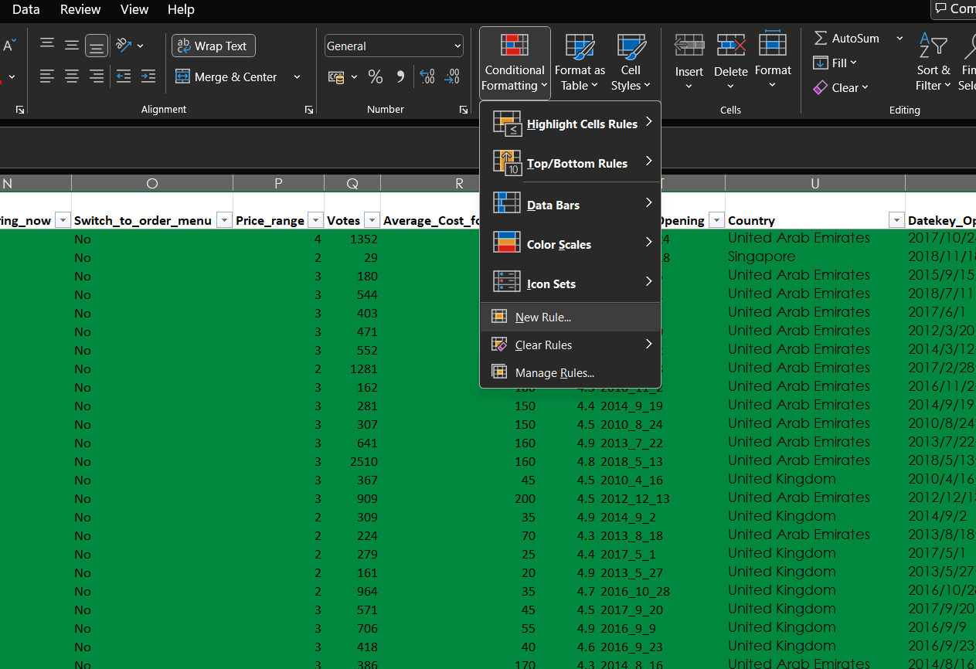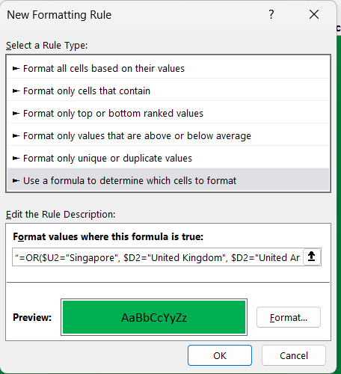
Formula: “=OR($U2="Singapore", $D2="United Kingdom", $D2="United Arab Emirates")”

Q12. Create a new customized price column that consists of the abbreviation/symbol of the currency along with the Average_cost_for_two value. [Use string operations to do this task]
Ans. =TRIM(MID(K2, FIND("(", K2) + 1, FIND(")", K2) - FIND("(", K2) - 1)) & R2
Q13. How can you create an array formula in Excel or Google Sheets to count the number of restaurants listed that do not offer online delivery, are in the lowest price range, and have an average cost for two people less than or equal to 250 Indian Rupees?
Ans.1694
Formula: =COUNTIFS('Raw Data'!M:M,"No",'Raw Data'!P:P,"1",'Raw Data'!Y:Y,"<=250")

Subjective Answer

Q1.Suggest a few countries where the team can open newer restaurants with lesser competition. Which visualization/technique will you use here to justify the suggestions?
Ans.
Approach:
-Use Pivot Table to examine distribution of restaurants by country.
-Selected the countries where online delivery and table booking is on the lower end however the Average cost is on the Higher End.
-The rating of restaurants is good in the suggested countries.

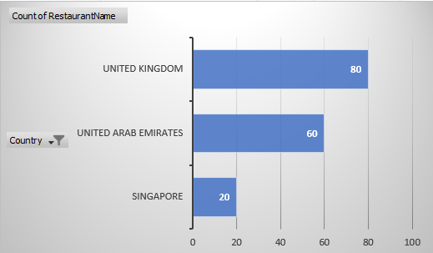
>Table for Has_Table_Booking.

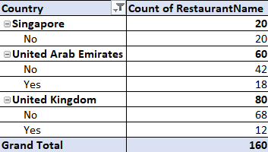
>Table for Has_Online_Delivery.
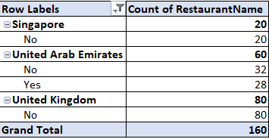

Insight:

- Low Market Saturation: Each of these countries has a relatively limited number of high-end restaurants, resulting in reduced competition and greater visibility for new entrants.
- Strong Tourism Appeal: As developed nations with well-established tourism infrastructure, these destinations are consistently favored by international travelers seeking premium experiences, including fine dining.
- Digital Service Gaps: There is a noticeable lack of restaurants offering online delivery and digital table booking services, indicating a valuable opportunity to differentiate through technology-driven customer convenience.

Recommendation: Based on strategic analysis and market potential, the most favorable countries for launching new luxury restaurants are:
- United Arab Emirates
- Singapore
- United Kingdom

Q2.Come up with the names of States and cities in the suggested countries suitable for opening restaurants.
Ans.
Approach:
•Use Pivot Table to aggregate number of restaurants on basis of city.
•Filter out the cities based on the suggested countries identified with least competition.
•Identify cities with least competition. sort the pivot Table in ascending order of no. of restaurants.
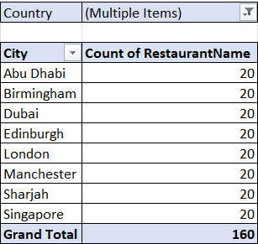
Insights:
- Leverage low luxury-segment saturation to launch a standout fine-dining concept with minimal competition and maximum visibility.
- Tap into the region’s strong tourist appeal by delivering exclusive, chef-driven experiences that resonate with international travelers.
- Differentiate through a seamless digital ecosystem—app-based bookings, real-time delivery tracking, and personalized online menus—to meet evolving guest expectations.

Recommendation: In the suggested countries we can open restaurants in these cities
Abu Dhabi, Birmingham, Dubai, Edinburgh, London, Manchester, Sharjah, Singapore
Q3. According to the countries you suggested, what is the current quality regarding ratings for restaurants that are open there?
Ans.
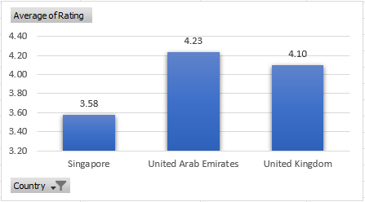
In evaluating potential markets for launching new luxury restaurants, we focused on three strategic locations:
Singapore
United Arab Emirates (UAE)
United Kingdom (UK)
Approach: We refined the dataset to include only restaurants located in Singapore, the UAE, and the UK. Using a Pivot Table, we calculated the average customer rating for restaurants in each country.A comparative chart was generated to illustrate the average ratings, enabling a clear assessment of market performance across the selected regions.
Insight: Historical data indicates consistently high performance across these regions, with average restaurant ratings exceeding 4.0 in both the UAE and UK. While Singapore shows slightly lower average ratings(3.58), this is offset by its exceptional market potential. As one of the world’s most visited destinations, Singapore boasts world-class infrastructure, a vibrant culinary scene, and strong appeal due to its renowned beaches, ports, and hospitality sector.
Recommendations:

• For High-Rated Countries:
- Leverage positive ratings for tourism marketing, promoting these countries as premium dining destinations.
- Maintain service and food quality to sustain high customer satisfaction.
• For Lower Rated Countries:
- Focus on improving service consistency and food quality to enhance customer experience.
- Analyze customer feedback to identify and address recurring issues.

Q4. Also, what is the current expenditure on food in the suggested countries, so we can keep our financial expenditure in control?

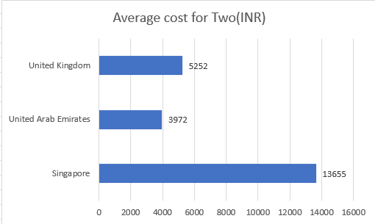

Approach: The database is filtered for Singapore, UAE, and the UK, with currency standardized to INR for consistency. A Pivot Table calculates total food expenditure per country, and a comparative chart visually highlights regional spending differences
Insights:
• Singapore (₹13,665) has the highest restaurant expenditures, indicating high spending power and demand for premium dining experiences.
• United Kingdom (₹5,252) shows moderate spending, suggesting potential for growth in mid-range dining options.
• UAE (₹3,972) has an extremely low expenditure, possibly indicating a lack of restaurant market presence or data collection gaps.
Recommendation:
• Menu and pricing strategy: Singapore show high spending potential, making them ideal targets for luxury and fine-dining investments.
• Optimize Expansion Budget: UK and UAE could benefit from affordable dining options and marketing strategies to boost spending.

Q5. Come up with the names of restaurants from the recommended states that are our biggest competitors and also those that are rated in the lower brackets, i.e. 1-2 or 2-3.
Ans. The listed restaurants—such as Bao, Carnival By Tresind, Duck & Waffle, and Punjab Grill—all maintain exceptional average ratings (≥4.85), signaling consistent excellence in food quality, service, and overall experience. Their presence across Singapore, UAE, and UK aligns with our target expansion markets, making them relevant benchmarks and strategic competitors.
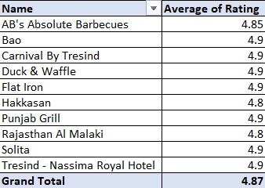

The establishments listed—Damascena Coffee House (1.0), Makansutra Gluttons Bay (3.0), Pepe's Piri Piri (2.8), and Pizza Hut (2.4)—have a grand average rating of just 2.3, indicating significant gaps in customer satisfaction, quality, or brand perception.
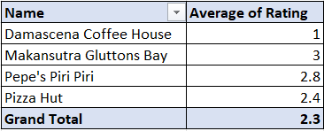

Criteria: Benchmark restaurants maintain ratings ≥4.85 across target markets, signaling excellence and strategic relevance.
Low-rated venues (≤3.0) reveal gaps ripe for disruption through quality, experience, and premium positioning.
Recommendation:

Only 4 establishments in our target markets currently fall into the lowest rating bracket. By emphasizing superior quality and delivering an unparalleled dining experience, we can expand market share and drive higher average spend per guest.

Q6. Which cuisines should we focus on in the newer restaurants to get better feedback? Does the choice of cuisines affect the restaurant ratings?
Ans. Yes. Cuisine type shapes diner expectations, emotional engagement, and perceived value. Restaurants serving cuisines known for craftsmanship, unique flavor profiles, and cultural storytelling consistently earn higher ratings than those offering generic or undifferentiated menus.
Criteria: Top-Performing Cuisines to Prioritize As they will generate high revenue for the newly opened restaurants.
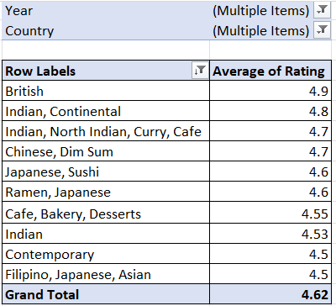
Approach:
Use Pivot Table and aggregate average of rating against every Cuisine.
Use filter by Country to contain only the suggested cities.
Use filter by year to identify last 3 year’s trends and how people rated restaurants according to most recent trends.
Filter the dataset to extract only top 10 rated Cuisines.

Recommendation:
Curate chef-driven specialty dishes within these high-performing cuisines to reinforce premium positioning.
Integrate local ingredients or regional twists to elevate authenticity and resonate with target markets.
Leverage seasonal menus (e.g., a rotating ramen bowl or steak night) to maintain excitement and repeat visitation.
Continuously track review platforms for cuisine-specific feedback and iterate rapidly on underperforming items.
Avoid generic fast-food or unfocused mash-ups, which dilute brand equity and depress ratings.

Q7. According to our current data, should we go for online delivery and table booking? Does that affect the customer’s ratings?
Ans.
Approach: Use two Pivot Table to calculate Online booking avg. ratings and Table booking avg. ratings across all restaurants respectively with the filter of Has Table booking and Has online delivery.
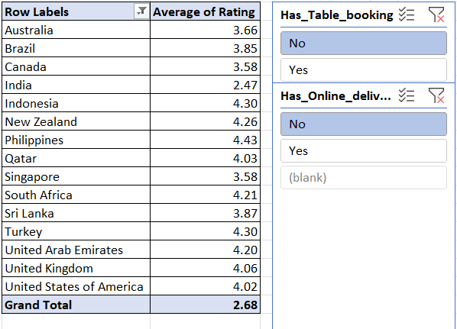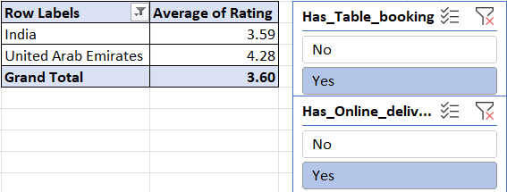

Criteria: Prioritize top 10 cuisines with highest average ratings over the last 3 years in target cities using pivot-based analysis.
Focus on chef-driven, culturally rich menus with seasonal innovation to elevate brand value and maximize revenue potential.
Insight: Data analysis shows that restaurants offering both online delivery and table booking services consistently achieve higher customer ratings, demonstrating that convenience features have a measurable impact on guest satisfaction.

Recommendation:
Integrate online ordering and reservation capabilities to streamline the customer experience and drive stronger reviews.

Q8. Should the team keep the rate of cuisines higher? Will that affect the feedback? According to our data are the rates of cuisines and ratings, correlated?

Ans. - Higher pricing does not guarantee better ratings, nor does lower pricing necessarily lead to poor feedback.
Countries like Turkey (₹182.43, 4.30) and Indonesia (₹1518.43, 4.30) show high ratings despite lower costs, while Singapore (₹10,625.27, 3.58) has high cost but average ratings.
This suggests that value perception, experience quality, and cultural expectations likely play a bigger role in feedback than price alone.
Recommendation
Do not increase prices solely to influence ratings—the data doesn’t support that strategy.
Instead, focus on:
Experience optimization: Ambience, service, presentation.
Localized pricing strategies: Align with market expectations and purchasing power.
Differentiation: Offer premium tiers or curated experiences for high-end markets without alienating value-seeking customers.

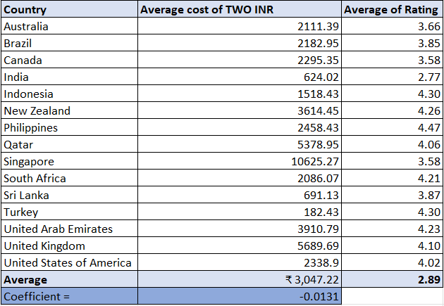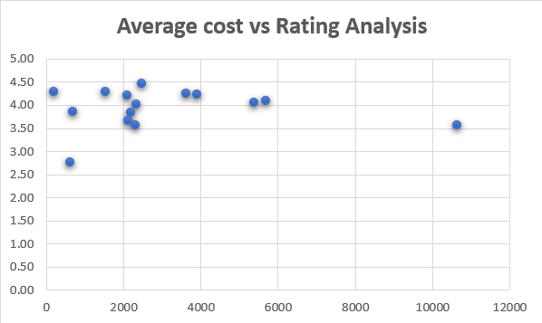

Q9. What is the distribution of the number of restaurants of different price ranges in all the countries?
Ans.
Criteria: Segment markets by pricing volume and tier distribution to identify strategic fit for premium, balanced, or value-led positioning.
Prioritize premium-heavy regions for luxury formats; tailor offerings in balanced or volume-driven markets for scale and accessibility.
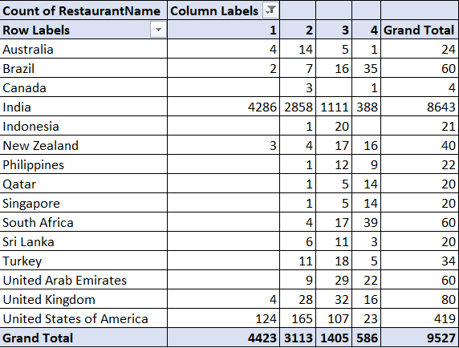
-Markets like India and USA with massive volumes in lower price ranges.
-Countries such as Brazil, South Africa, and UAE showing notable splits toward premium tiers.
-Regions like Canada, Indonesia, and Sri Lanka with lighter overall volumes but varying tier representation.
-Singapore and UAE are premium-heavy markets—ideal for luxury positioning and curated experiences.
-UK offers a more balanced pricing landscape with strong digital engagement and health-conscious consumers.

Q10. Explain your approach in brief for suggesting countries/cities in order to open new restaurants, if the objective and subjective questions would have not been given to assist you. [you have to give bullet pointers in order to answer this question]
Ans.
- Restaurant Density Analysis
Prioritize countries and cities with lower restaurant density, enabling entry into less saturated markets. This approach minimizes direct competition and enhances the potential to establish a strong brand presence and customer base.
-Affluent Market Targeting
Focus on cities where the average cost for two is relatively high, signaling greater consumer spending capacity. These markets present an opportunity to introduce affordable yet high-quality dining options, appealing to a broader demographic while maintaining perceived value.
- Customer Satisfaction Benchmarking
Select cities and cuisines with consistently high customer ratings, as these reflect strong consumer preferences and satisfaction. Leveraging these insights supports effective menu positioning, brand alignment, and targeted marketing strategies.
-Digital Infrastructure Alignment
Prioritize countries that support both online delivery and table booking services, as these digital capabilities significantly enhance operational efficiency, customer convenience, and overall sales performance.

